LIBRARY MANAGEMENT SYSTEM

**Revision History**

| **Version** | **Date** | **Author** | **Description** |
| --- | --- | --- | --- |
| 0.10 | 17/11/23 | Josh L. | Document structure added |
| 0.20 | 18/11/23 | Josh L. | Rewrite of Business Requirement Document |
| 0.30 | 19/11/23 | Josh L. | UML Diagrams: EER added |
| 0.40 | 20/11/23 | Josh L. | Normalization on Database |
| 0.50 | 21/11/23 | Josh L. | Business Rules Formulated |
| 0.60 | 21/11/23 | Josh L. | Data Correction for Database |
| 0.70 | 22/11/23 | Josh L. | Added DB Tables to document |
| 0.80 | 22/11/23 | Josh L. | Database Design Completion |
| 0.90 | 23/11/23 | Josh L. | JDBC Connector Established |
| 1.00 | 24/11/23 | Josh L. | Removed User Manual |
| 1.10 | 25/11/23 | Josh L. | Added Class Diagram |
| 1.20 | 15/12/23 | Josh L. | Added Sequence Diagram |
| 1.30 | 16/12/23 | Josh L. | System Requirement Specs |
| 1.40 | 17/12/23 | Josh L. | Project Structure Writeup |
| 1.50 | 18/12/23 | Josh L. |  |

This is a structured outline for my Library Management System Documentation.

Contents

BUSINESS REQUIREMENTS DOCUMENT 3

PURPOSE 3

OBJECTIVES 3

SCOPE 3

RULES 3

ASSUMPTIONS 4

CONSTRAINTS 4

PROJECT DELIVERABLES 4

BACKEND 4

FRONTEND 4

SYSTEM REQUIREMENTS SPECIFICATION 4

SYSTEM ARCHITECTURE 5

SYSTEM DIAGAM 5

System Overview 5

Technology 6

Project Structure 6

Integration 7

FUNCTIONAL REQUIREMENTS 7

User Management 8

Book Management 8

Borrowing and Returning 8

Reporting and Analytics 8

NON-FUNCTIONAL REQUIREMENTS 9

PERFORMANCE 9

SECURITY 10

USABILITY 10

RELIABILITY 10

SCALABILITY 11

DESIGN DOCUMENTS 11

DATABASE DESIGN 11

INDEXES 12

SCHEMA 12

TABLES 12

COLUMNS 13

Entities and Attributes 15

Relationships between Entities 16

UML DIAGRAMS 16

enhanced entity-relationship diagram 16

USE CASE DIAGRAM 18

CLASS DIAGRAM 20

SEQUENCE DIAGRAM 24

SYSTEMS DIAGRAM 24

WIREFRAMES 24

# BUSINESS REQUIREMENTS DOCUMENT

**This document outlines the business requirements, objectives, scope, and constraints of the project. It provides a high-level view of what the system is intended to accomplish.**

## PURPOSE

A new library housed inside a private residence is started. It currently has 2 staff is in process of stocking books. The library has WIFI facilities and is open to a resident size of 250. It is not open to public. As the facilities is still very new, less then 10% of residence have registered as library member. Members, books volume is expected to increase as more complete their renovation and start to move in to premise. More librarians will also be hired along the way.

The purpose of this Library Management System (LMS) is to streamline the processes involved in managing a library's resources, including books, periodicals, and user information.

## OBJECTIVES

* Improve efficiency in library operations.
* Enhance user experience for both staff and library patrons.
* Provide accurate and real-time information on library resources.

## SCOPE

The LMS will cover administrative functionalities to assist librarians in managing this library.

### RULES

1. Each member can borrow up to 8 books at once.
2. Each book borrowed is for 3 weeks.
3. Staff can only borrow book as regular member. And all library rules shall apply for staff.
4. This library uses standard ISBN13 convention for book numbering.
5. Library fines or late fees are imposed on books not returned or is returned late.
6. Library fines must be paid over the counter to a librarian before borrowing can commerce.
7. Booking ID is the session of booking. No members can share a common booking ID.
8. User ID is either the Member ID or Staff ID. If staff borrows in this library, standard borrowing rules (Including fines) shall apply.
9. The system log in is User ID and password. Currently only staff are required to log in as members can browse freely in guest mode.
10. Password used must be combination of uppercase letters, lowercase letters, numbers, and symbols. And contain at least 9 characters.
11. Each library Booking Id is 1 book. Member’s Booking Id field is updated to most recent borrowing activity of the particular member.

### ASSUMPTIONS

1. The library does not stock duplicate titles. Only 1 copy per title.
2. All staffers are library members and have library Member Id.
3. Library book availability status is maintained by Staffs upon receiving book return and keying the update into system.
4. If book status is ‘Available’, this means the book is ready to be loaned again.
5. If book status is ‘On Loan’, this means the book is currently unavailable.
6. Book index is physical location of book in library.

### CONSTRAINTS

* The system should be implemented within 1 month from November 2023 with required paperwork and source code submitted.

# PROJECT DELIVERABLES

## BACKEND

* + Spring Boot application with RESTful APIs
  + Database schema and data migration scripts
  + Unit tests for backend components

## FRONTEND

* + ReactJS application with user interface components
  + Routing and navigation between different pages
  + Integration with backend APIs for data fetching and manipulation

# SYSTEM REQUIREMENTS SPECIFICATION

**The SRS document provides detailed technical specifications, including functional and non-functional requirements. It describes the system's behavior, interfaces, data structures, and more.**

## SYSTEM ARCHITECTURE

**System Architecture Design: Describes the high-level architecture of the system, including how the frontend and backend components interact, and the database structure.**

### SYSTEM DIAGAM

* Spring Boot exports REST Apis using Spring Web MVC & interacts with Database using Spring JPA
* React Client sends HTTP Requests and retrieve HTTP Responses using axios, shows data on the components.
* We use React Router for navigating to pages.
* Database will either be MySQL or PostgreSQL.

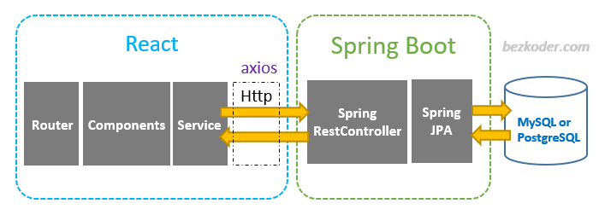

## System Overview

The Library Management System or (LMS) in short will be a web-based application with a client-server architecture. It will include a user interface accessible through web browsers and a backend database to store and manage data.

We explore building a full stack Spring Boot + React.js + MySQL example with a CRUD App. The back-end server uses Spring Boot with Spring Web MVC for REST APIs and Spring Data JPA for interacting with MySQL/PostgreSQL database. Front-end side is made with React, React Router, Axios & Bootstrap.

### Technology

* Java 17 / 11 / 8
* Spring Boot 3 / 2 (with Spring Web MVC, Spring Data JPA)
* MySQL
* Maven

### Project Structure

1. Book data model class corresponds to entity and table tutorials.
2. BookRepository is an interface that extends JpaRepository for CRUD methods and custom finder methods. It will be autowired in BookRestController.
3. BookRestController is a RestController which has request mapping methods for RESTful requests such as: getAllBooks, createBook, updateBook, deleteBook, findByBook…
4. Configuration for Spring Datasource, JPA & Hibernate in application.properties.
5. pom.xml contains dependencies for Spring Boot and MySQL.

### Integration

JDBC CONNECTION

LMS will integrate with external systems for ISBN databases for book information.

# FUNCTIONAL REQUIREMENTS

Staffs making use of the system will be able to do the following:

* Create, edit, and delete user accounts.
* Manage user roles and permissions.
* Track user borrowing history.
* Add, edit, and delete book records.
* Categorize books using genres and subjects.
* Maintain book availability status.

Staff can also generate reports to:

* Maintain book availability status.
* Generate reports on book usage and borrowing trends
* Analyze user borrowing patterns
* Track overdue books and generate notifications
* Export reports in different formats (e.g., PDF, CSV).

3.1 User Management

* Ability to add, edit, and delete library staff and patrons.

3.2 Catalog Management

* Add, edit, and delete books with details such as title, author, ISBN, and genre.
* Track book availability, status, and location.

3.3 Circulation

* Check-in and check-out of books.
* Reservation and hold functionalities.
* Overdue book notifications.

3.4 Reporting

* Generate reports on book availability, user activities, and overdue books.

3.5 Search and Discovery

* Integration with external databases for additional resource information.

In Summary

## User Management

o Create, edit, and delete user accounts

o Manage user roles and permissions

o Track user borrowing history

## Book Management

o Add, edit, and delete book records

o Categorize books using genres and subjects

o Maintain book availability status

## Borrowing and Returning

o Allow users to search for available books

o Facilitate borrowing requests for available books

o Manage borrowing periods and due dates

o Enable book returns and update book availability

## Reporting and Analytics

o Generate reports on book usage and borrowing trends

o Analyze user borrowing patterns

o Track overdue books and generate notifications

1. Member Kai is likely either Christian or a highly religious person from his borrowing activities he loaned ‘An Introduction to the Old Testament ‘and later ‘The Epic of Eden’. Both of similar book genre.
2. Member White has loaned out “Harry Potter and the Cursed Child”, “Fantastic Beasts: The Secrets of Dumbledore” Indicating a demand for children’s books. The library could do well to stock more of such genre as more residents start to move in and become a library member.
3. Member White’s library activities suggest he could be child age or have children at home who reads R K Rowlings’ books.
4. Member Dusan is quite a thriller fan. He borrowed all Dan Brown’s books and  
   is likely to return for next Dan Brown’s thriller book once done with current reading.
5. Only member Drake has outstanding uncleared library fine.
6. The missing book from library is with Ivan Toney, book titled “Man's Search for Meaning”. Borrowed since 5th Feb 2023. Book status is still ‘On Loan’ and Toney has since incurred a $11 fine.
7. Member Ivan Toney cannot borrow anymore books because of outstanding library fines amounting $11.00. Hence Toney has no borrowing activities of late.

# NON-FUNCTIONAL REQUIREMENTS

The library system will have these facilities for members:

* Authentication and authorization mechanisms to control access.
* Allow users to search for available books.
* Facilitate borrowing requests for available books.
* Manage borrowing periods and due dates.
* Enable book returns and update book availability.
* Advanced search capabilities for library resources.

In Summary

## PERFORMANCE

* + The system should be able to handle many concurrent users without performance degradation
  + Book search and filtering operations should be efficient and responsive
  + Response time for common operations should be within acceptable limits.

## SECURITY

A unique 25 alpha numerical password will be generated.   
For example: c761658c-a0f3-497b-9719-ef179cdffd29

* + Implement secure user authentication and authorization mechanisms.
  + Basic form of form verification on login page.
  + Protect sensitive data, such as user information and borrowing records.
  + Prevent unauthorized access to library resources

## USABILITY

* + The system should have a user-friendly interface that is easy to navigate and understand
  + Provide clear instructions and guidance for users
  + Implement consistent design patterns across the frontend and backend
  + The system should be scalable to accommodate a growing number of books and users.

## RELIABILITY

* + The system should be available 24/7 with minimal downtime for maintenance.

## SCALABILITY

* + system should be scalable to accommodate a growing number of books and users

4.1 Performance

* The system should handle simultaneous user requests efficiently.

4.2 Scalability

* The system should be scalable to accommodate a growing number of books and users.

4.3 Security

* Secure user authentication and authorization.
* Encryption of sensitive data during transmission.

4.4 Reliability

* The system should be available 24/7 with minimal downtime for maintenance.

4.5 Usability

* Intuitive user interface for both library staff and patrons.
* User training and support documentation.

# DESIGN DOCUMENTS

* Java is very handy with number of data bases you can use their jars to add connections and you can perform crud operation in Java.
* Here we use Java as a backend, then spring boot for creating a microservices which act as a restful API for frontend in react JS.

## **DATABASE DESIGN**

* + **Database Design: Contains details about the database schema, including tables, relationships, and data constraints.**

### INDEXES

### **SCHEMA**

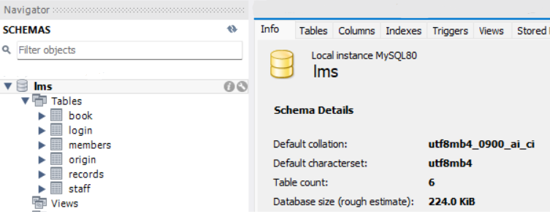

### **TABLES**

### **COLUMNS**

**  
**

#### Staff

#### **Members**

#### **Login**

#### Records

#### Book

#### Origin

### **Entities and Attributes**

**Staff Entity: It has Staff_Joindate, Password, Staff_Id, Staff_Name, Staff_Position. Staff_Id is Primary Key.**

**Login Entity: It has Staff_Id, Staff_Email, Member_Mobile, Member_Email, Member_Id, Booking_Id  
Login_Id is the Primary Key for Login Entity.  
Booking_Id, Staff_Id, Member_Id are Foreign Keys for Login Entity.**

**Book Entity: It has Pages, Title, Category, Author.   
Title is the Primary Key for Book Entity.  
Isbn is Foreign Key for Book Entity.**

**Members Entity: It has** **Member_Id, Email, Member_Name, Member_Mobile, Fine Member_Email. Member_Id is the Primary Key for Members Entity.  
User_Id is Foreign Key for Members Entity.**

**Origin Entity: It has Genre, Publisher, YearOfPublication.   
ISBN is Primary Key of for Origin Entity.  
Index_No is Foreign Key for Origin Entity.**

**Records Entity: It has Book_Status, Booking_Date, Index, Booking_Id   
Index is the Primary Key for Records Entity.  
Staff_Id is 1 of the 4 Foreign Keys for Records Entity.  
Member_Id is 1 of the 4 Foreign Keys for Records Entity.  
Title is 1 of the 4 Foreign Keys for Records Entity.   
Isbn is 1 of the 4 Foreign Keys for Records Entity.**

### Relationships between Entities

1. **Each employee can only do 1 login session to the main library system for purpose of checking book status and indexed placing in the library.**
2. **Members are free to use library system to first check book availability through book status, and make a booking reservation to borrow it. No log in required however each member can have just 1 active browsing session with library system. Starting multiple sessions by single member is disallowed.**
3. **The library only has 1 centralised system and the system will reflect multiple book records at once.**
4. **Every book have 1 publication source.**
5. **The system also reveal multiple sources so that members can search base on a favourited publisher or book source.**

## UML DIAGRAMS

enhanced entity-relationship diagram

**The Enhanced ER Diagram include foreign keys necessary to relate to other tables.**

### USE CASE DIAGRAM

Code:

@startuml

actor Staff as s

actor Member as m

left to right direction

package login{

usecase "Login_Id" as UC1

usecase "Staff_Id"

usecase "Member_Id"

usecase "Staff_Mobile"

usecase "Staff_Email"

usecase "Booking_Id"

usecase "Member_Email"

usecase "Member_Mobile"

}

package staff{

usecase "Staff_Id"

usecase "Staff_Joindate"

usecase "Password"

usecase "Staff_Position"

usecase "Staff_Name"

}

package origin{

usecase "ISBN"

usecase "YearOfPublication"

usecase "Genre"

usecase "Publisher"

usecase "Index_No"

}

package records{

usecase "ISBN" as UC10

usecase "Title" as UC2

usecase "Index_No" as UC3

usecase "Booking_ID" as UC4

usecase "Booking_Date" as UC5

usecase "Booking_Status" as UC6

usecase "Fine" as UC7

usecase "Login_Id" as UC8

usecase "Member_Id" as UC9

}

package book{

usecase "Category"

usecase "Title"

usecase "Author"

usecase "Pages"

s --> UC1

m --> UC6

@enduml

Source URL:

<https://www.plantuml.com/plantuml/duml/VPFFJW8n48VlVOfcxoJ-KTIBGK0DHf04FNWYixkpIqEtOzhPg26-koasfCistiZtJUOtJ6T7Zi5ossW11PELAuQgak2a2s2EJOxMaqPeh5WoIQlg3SjIMInOaH7Y0uejr2WrrShiX9Ijmm8SokpPa_Mip7o7jybfxFPPtiNmBy_JVkcSSgKn8UuRKBh3nqHRPUfqzr3V5uU4dyDVSZvWbnox3vz8cH8OEse9pdsIJTKloIc_mOHQGBEVup08MNMytDbglCXYy8vWNwfbcsjLGA_n8nfxD9glT1kq7Jep9Nwj5zI9jrYGBLq_FppiIInU5MiCvYpLEhZpv9DDWxr8sIam1d-PyYi6Rbse6COL3yfWu5V_dEXryXg3l8ak8oVQTjOn0SQQx7VMNqLCxbhUa3qwaHfT9eIJWy7j_ZDfmg-X6A4fsqR_0W00>

### CLASS DIAGRAM

Source Code:

@startuml

!define DARKGREEN

class Login{

int Login_Id

int Booking_Id

String Staff_Id

String Member_Id

String Staff_Email

String Member_Email

int Member_Mobile

int Staff_Mobile

}

class Staff{

String Staff_Id

String Staff_Name

String Staff_Joindate

String Staff_Position

String Password

}

class Members{

String Member_Id

int Booking_Id

String Member_Name

int Fine

String User_Id

}

class Origin{

String Genre

String YearOfPublication

String Publisher

float Index_No

String Book_Title

}

class Records{

int Booking_Id

int Fine

String Staff_Id

String Member_Id

String Isbn

}

Class Book{

String Title

String Author

String Categor

String Isbn

}

Book <.. Origin

Records <.. Staff

Records <.. Members

Members <.. Login

Staff <.. Login

@enduml

URL: <https://www.plantuml.com/plantuml/duml/VPFFJW8n48VlVOfcxoJ-KTIBGK0DHf04FNWYixkpIqEtOzhPg26-koasfCistiZtJUOtJ6T7Zi5ossW11PELAuQgak2a2s2EJOxMaqPeh5WoIQlg3SjIMInOaH7Y0uejr2WrrShiX9Ijmm8SokpPa_Mip7o7jybfxFPPtiNmBy_JVkcSSgKn8UuRKBh3nqHRPUfqzr3V5uU4dyDVSZvWbnox3vz8cH8OEse9pdsIJTKloIc_mOHQGBEVup08MNMytDbglCXYy8vWNwfbcsjLGA_n8nfxD9glT1kq7Jep9Nwj5zI9jrYGBLq_FppiIInU5MiCvYpLEhZpv9DDWxr8sIam1d-PyYi6Rbse6COL3yfWu5V_dEXryXg3l8ak8oVQTjOn0SQQx7VMNqLCxbhUa3qwaHfT9eIJWy7j_ZDfmg-X6A4fsqR_0W00>

### SEQUENCE DIAGRAM

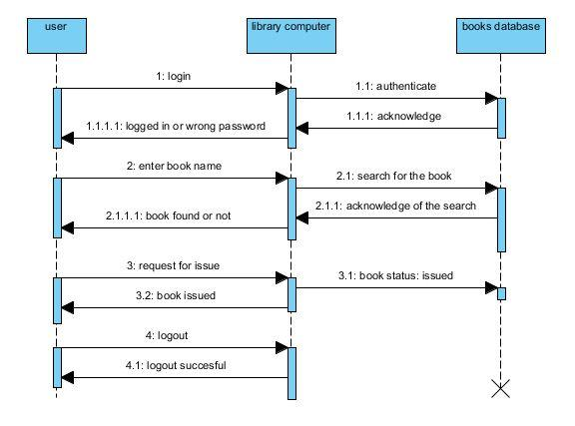

## SYSTEMS DIAGRAM

## WIREFRAMES

Login Page

* + **UI/UX Design: Includes wireframes and mockups of the user interfaces in the React.js frontend.**

**Note

**Project Success Criteria:**

* The system meets all functional and non-functional requirements.
* The system is successfully deployed and used by librarians, students, and faculty members.
* The system receives positive feedback from users regarding its ease of use and functionality.
* The system demonstrates improved efficiency in library management operations.